Shabbos Stories for
Parshas Tazria-Metzora 5773
Volume 4, Issue 31 3 Iyaar 5773/ April 13, 2013
For a free subscription, please forward your request to keren18@juno.com

Chassidic Story #801

The Most Desirable Apples
From the desk of Yerachmiel Tilles
Editor@ascentofsafed.com

One day late in the week, a poor woman who was from a well-respected Jewish family knocked on the door of the Divrei Chaim of Sanz. She requested his financial help, saying plaintively that she had yet to accrue sufficient funds to purchase the necessities for Shabbat.
The Divrei Chaim was surprised. “Don’t you have a stall for selling apples in the marketplace?” he asked. “Why is it that you have no money?”
She explained that people were saying that her apples were of inferior quality, and as a result she hardly been able to sell any this week.
When the Rebbe heard the cause of her problem, he rose and, adorned in his elegant rabbinic robe and Chasidic hat, strode off to the woman’s stall in the marketplace. The shoppers were astonished to see him there and the word of it spread quickly.

The Rebbe Hawks the Woman’s Apples
The Rebbe ignored their stares and calmly assumed a place behind the seller’s table. “My fellow Jews!” he called out. “Here are good apples for sale, very good apples, excellent apples. Who wants to buy them?”
Immediately there was a jostling stampede towards the apple-vendor’s table. People offered two, three, ten times the official price of the apples, because everybody wanted to buy the fruit directly from the hand of the holy Divrei Chaim of Sanz. In a very short time all the apples were sold for exorbitant amounts, and the Rebbe handed over to the woman a sum of money so large she could barely believe that it had come only from her apples.

“Your Apples Were of Good Quality”
“Look,” said the Rebbe, “your apples were of good quality; it is just that the townspeople didn’t realize it until today.”
Source: Translated by Yerachmiel Tilles from Sipurei Chasidim (#299) by Rabbi S. Y. Zevin.
Connection: Seasonal--137th yahrzeit of the Divrei Chaim of Sanz
Biographical note: Rabbi Chaim Halberstam of Sanz [1793 - 25 Nissan 1876] was the first Rebbe of the Sanz-Klausenberg dynasty. He is famous for his extraordinary dedication to the mitzvah of tzedaka and also as a renowned Torah scholar; his voluminous and wide-ranging writings were all published under the title Divrei Chaim. His eldest son founded the famous Sanzer synagogue in Tsfat in the middle 1800's.

Reprinted from last week’s email of KabbalaOnline, a project of Ascent of Safed. www.ascentofsafed.com ascent@ascentofsafed.com

The Rabbi Who
Saved Passover
By Gil Shefler

L.A. Jews spared from serving a vegetarian Seder meal by a last-minute Kashrut ruling

NEW YORK (JTA) — Less than a day before the start of Passover, the phone rang at the Brooklyn home of Rabbi Yisroel Belsky. On the line were concerned members of the Rabbinical Council of California, a rabbinical association in Los Angeles that provides kosher certification, among other services.
The RCC had just discovered that Mike Engelman, the owner of Doheny Glatt Kosher Meats, had smuggled uncertified meat into his store, and the West Coast rabbis needed the guidance of their East Coast colleague.
“It was obvious to all of us that we needed an unbiased decision from an expert outside the community, with vast knowledge and experience, to give an authoritative decision that the members of this community would rely upon,” Rabbi Avrohom Union, the rabbinic administrator of the RCC, told JTA in an email.

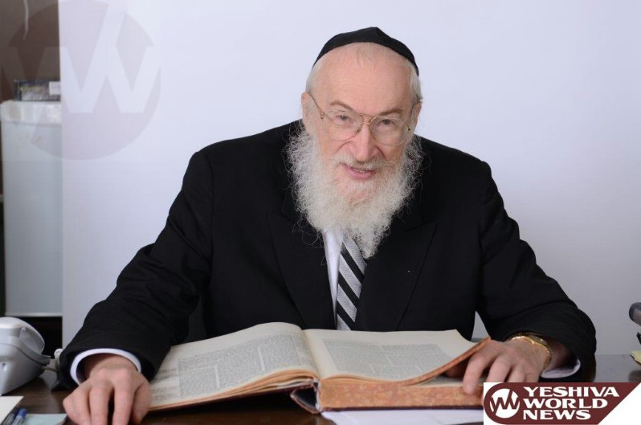

Rabbi Yisroel Belsky

People Might Have Been Forced to
Toss Their Foods [into the Garbage]
Now [Rabbi] Belsky, a well-respected arbiter of religious law, had a big decision on his plate. If he determined all the meat was tainted, observant Angelenos may have been forced to toss all the foods they prepared for Passover [into the garbage], which started on the evening of March 25.
“People would have been served salad on Passover night,” said Rabbi Meyer May, the RCC president.
After weighing the information, [Rabbi] Belsky made a ruling: All meat sold prior to March 24, the day the news of the alleged transgressions came to light, was kosher — even though a small portion was not properly certified. Passover was saved — barely.

Kosher Violations are Rare, But Not Unheard of
Kosher violations like this are rare, but not unheard of. News emerges occasionally that a trusted vendor sold clients food that either intentionally or unintentionally did not comply with the strict dietary stipulations of Jewish law.
Police in London in 1928 had to prevent an angry mob from storming a cafe that sold unkosher meat as kosher. In 1986, a court fined Rachleff Kosher Provisions in Brooklyn more than $1 million for selling thousands of pounds of non-kosher tongue and brisket. In 2006, in one of the worst violations in recent memory, Shevach Meats, a supermarket in the largely Orthodox community of Monsey, N.Y., was discovered to have intentionally sold non-kosher items to its unsuspecting clientele.

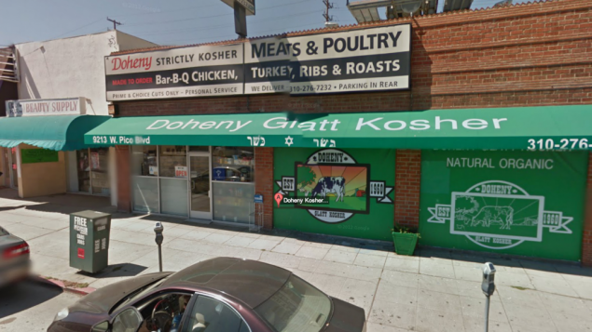Doheny Glatt Kosher Meats will open under new management soon after being shut down because its owner smuggled uncertified meat into the popular Los Angeles market (photo credit: JTA)

Some rabbis in Monsey and nearby Spring Valley — though not all — told followers they had to remake their kitchens as kosher, an arduous process that involves boiling pots and pans and passing utensils over an open flame. Some kitchenware that comes into contact with unkosher food is considered irredeemable and thrown out.

“It Was Extremely Shocking”
“It was extremely shocking because many, many people really viewed this grocery as the most reliable place to get your chicken,” said Rikki Davidson, a 28-year-old homemaker from Monsey. “All the caterers purchased chicken from him.”
What exactly happened at Doheny Market is still unclear. On March 12, Engelman was caught on videotape directing his employees to unload boxes of meat from his car while the market’s kosher supervisor was absent. Engelman reportedly claimed the meat wasn’t unkosher, just not glatt — a higher kosher standard.
But the RCC revoked the shop’s kosher certification on March 24 and the US Department of Agriculture has launched an investigation. Within days, the market was sold to businessman Shlomo Rechnitz, Belsky’s son-in-law, who vowed to ensure it strictly complied with dietary laws.

A New Start for Meat Shop
“The store will reopen in the coming days under RCC supervision after undergoing a thorough restocking and will feature mehadrin kashrus standards,” the RCC said in a statement, referring to the most stringent kosher supervision. “The previous owner has no financial or operational interest in the store.”
Still, for the untold numbers who bought meat from Engelman, the scandal constituted a profound betrayal of trust.
“I’d say hello to Engelman if I saw him on the street, but I would not invite him to dinner,” said May, who also is the executive director of the Simon Wiesenthal Center. “I don’t have people I don’t trust in my life.”
Avrom Pollak, the president of Star K, a kosher certifier in Baltimore, said his outfit frequently dealt with clients who tried to cut corners. His supervisors recently caught a caterer trying to sell non-kosher turkey to clients.
“The rabbi remembered the kosher butchers in the area don’t kill turkeys that size,” Pollak said. “We asked to see the invoices and saw the top was torn off, so the name was not available.”

Looking at New Technology
To Uphold Dietary Regulations
Rabbi Menachem Genack, the CEO of the Orthodox Union’s Kosher Division, the largest kosher certifier in the world, said his organization was looking at new technology to help uphold dietary regulations.
“Over the last few months we’ve been talking to people about whether products at slaughterhouses can be given a unique label,” he said. “There is a specific scanner that will be able to check each number assigned to each piece of meat.”
The RCC said Doheny Market will reopen with new management and increased scrutiny over the next couple of days. Still, Rabbi May said even with the best practices in place, errors can occur.
“Greed exists in the world, so you always have the potential for it and anyone can circumvent the system and make a little bit of money,” he said. “The system was very good and exceeded the national standard. But we had a human failure.”

Reprinted from the April 5, 2013 edition of The Times of Israel

A Slice of Life
An Australian
Shabbos Saga
By Goldie (Feld) Goldbloom

There was Sara and there was Laura.
My two problems on the horizon, proverbial blots in the copy-book of an otherwise good year. I honestly didn't know what to do with either one.
I was working two jobs; the morning as a kindergarten teacher, and the afternoon as a Jewish chaplain in a large, Australian hospital. My students were a motley crew, mainly from non-religious homes, mainly boys with a penchant for Batman. I had them pretty much in control when Laura arrived. Funny, I thought she was shy when I first saw her.
Big black eyes fringed with long lashes. Blink. A tear dropped out. Another. Crocodile tears for Mummy on the first day. She oozed around the cubbies and clung to her mother's leg. Mum gave her an impatient push and said, "Do grow up, Laura! Here's your lunch. That's Miss Feld. Call her 'Miss.'" Then she was off.
Laura took one look at Miss and gave a dreadful howl. Then she threw her lunch at me, and whilst I was dealing with a cheese and tomato sandwich gone soggy, she bit Randy on the cheek. I did say she was a blot.

A Big Prize for Trouble
I tried everything with that girl, but she was Trouble. Little monster, I loved her anyway. We had a Big Prize for trouble, and those who made it. I was dying to use it on her. A Polaroid instamatic. Just when Trouble was--let's say--helping the Janitor (i.e., giving the broom a whirl), Miss would snap her picture. Being good. And then we'd hang it up and say, "Oh look, there's Laura cleaning up!" A dirty trick, but it worked wonders.
At the Shabbat party, I took Laura's picture, lighting the candles. She looked very sweet.
It didn't help. On the weekend, she tried to repeat the performance, and her non-religious family assumed she was trying to burn down the house. On Monday, there was No More Laura. Apparently sent off to some other school where Miss didn't teach the kiddies to play with matches. (I really hadn't!)

Discovers Sara in the Hospital
At any rate, I forgot about Laura pretty quickly, since I discovered Sara.
She was about 80, I'd say. An old dear who had had a rather drastic stroke. She was left completely immobilized, and unable to speak. I liked her immediately, as is my way with older ladies. Of course, it was a bit hard to communicate with her.
Actually, I lie. It was impossible to communicate with her. She lay unmoving, a slow stream of grey drool inching out of her mouth, occasional stomach noises disrupting the unearthly quiet in her secluded room.
Oh yes, you could tell they thought she was going to die. She was stuffed in an awful, windowless room, as far away from the nurses' desk as it could be.

Tried to Tell Her Funny Stories
As a chaplain, I was supposed to brighten her day. It was a bit hard. I told funny stories. I brushed her hair. She just slipped further and further into Cotton Wool Land. A belch would surprise me, and I'd utter some inane comment on how cholent beans had risen in price by two cents. She wasn't interested.
I tried Russian. Yiddish? I threw in some Finnish and Italian to spice it up. How about Hebrew? No takers. I showed her my Shabbos candles, and she groaned.
Well, she groaned and squeezed my hand. It was like having a dead body suddenly ask for a cup of tea. I ran to tell the nurses, who told me kindly and sympathetically that I needed my head read, and NO! She could NOT light candles in her room.
Poor Sara.
Well, I had another good idea up my sleeve. I went home and made her a mobile of photographs of Shabbos candles. Some girls lighting them. Some shining nicely by themselves. And I hung it over her bed where she could see it.
Sara certainly loved that mobile. Her eyes wandered mistily over it and leaked poor old tears down her yellow face. I was so glad that I had done it for her. Even though she never acknowledged my presence in any way, those tears were her quiet thanks.
The next week, she wasn't there. The mobile spun lazily in the air from the vent, but one photo had been cut off. Laura lighting her Shabbos candles. I went to the nurses' station to find out what happened.

Holding a Picture of a Little
Girl Lighting Jewish Candles
"Oh yeah," she chewed methodically, "That old biddy was real religious. Her daughter was more 'normal,' and said just feed her pureed whatever. Don't worry about kosher. Funny thing though. The old lady somehow grabbed that gizmo in there in the night, and was holding a picture of a little kid when she died. Gave her daughter a nasty turn. Couldn't figure out how she got a picture of her granddaughter lighting Jewish candles. Said she never did it. Ever."

Reprinted from the archives of “L’Chaim (issue #264 – Parshas Tazria-Metzora 5753/1993), a publication of the Lubavitch Youth Organization in Brooklyn, New York.

We Are All Survivors!
By Rabbi Israel Meir Lau
Former Chief Rabbi (Ashkenazi) of Israel

"Those who endured the horrors of the camps are not the only Holocaust survivors. That group includes a wide range of Jews from all over the world. At the beginning of the 1980s, Ed Koch, mayor of New York City, invited me to his office. He is*a warm Jew, sensitive and emotional, a great lover of Israel and the Jewish people.
At our first meeting, he introduced himself to me and declared that he was also a Holocaust survivor. Out of politeness, I refrained from asking him what exactly he survived and where he had been during the Second World War. I wanted to give him a chance to tell his story himself.
He said that he had been born in the Bronx and had lived his whole life in New York, but insisted that he was a real survivor. Smiling, I dared to ask how that could be- and Ed Koch began to explain.
Years earlier, he had traveled to Germany for an educational trip. At one of the stops, the guide showed the group the globe that had sat on Hitler's desk. "It reminded me of Charlie Chaplain's movie about the great dictator. But unlike the one in Chaplain's movie," Koch recounted, "that big globe had lots of numbers written on it in black marker.

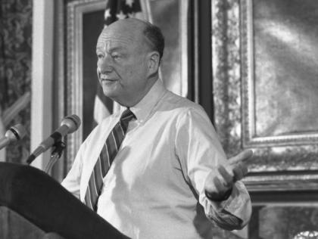
Former Mayor Ed Koch at a press conference in City Hall

“When the guide spun the globe, Europe blackened with numbers. Other continents had far fewer black marks. The guide explained that when World War II broke out, Hitler recorded the Jewish population of each country. After all, they represented his life's goal. Albania, for example, bore the number 1 for the single Jew living there.

Bothered by that One Jew in Albania
“Our enemy decided that he would not rest as long as that one Jew from Albania, a total stranger to him, remained alive. The territory of the United States bore the number six million.[The population statistics are slightly inaccurate] That includes me," said Ed Koch with undisguised anger. "So I am also a Holocaust survivor-if the Allies hadn't stopped the Nazi beast, no doubt I would have been destroyed."
I shook his hand warmly and said, "Today I have learned an important lesson from you, and I will carry it home with me to Israel. I've heard that not all Jewish communities feel a connection to Holocaust Day. From now on, I'll tell them about the Jew born in New York who lived all his life in an American city, but who feels like a Holocaust survivor..."

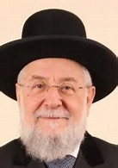
Rabbi Israel Meir Lau

A story From Rabbi Israel Meir Lau's book "Out of the Depths" (p. 241-242) *Mayor Ed Koch z"l died this year, February 1, 2013, at age 88

Reprinted from the April 8, 2013 email of the Shehebar Sephardic Center.

Buchenwald Liberated (1945)

The Buchenwald concentration camp was founded in 1937 near the town of Weimar, Germany. Approximately 250,000 prisoners were incarcerated in this camp until its liberation in 1945.
Weimar is a German city known for its highly cultured citizenry. It was the home of many of the upper class intellectual members of Europe’s society. Among others, Goethe, Schiller, Franz Liszt, and Bach lived in Weimar.
Though technically not an extermination camp, approximately 56,000 prisoners were murdered in Buchenwald (not including many others who died after being transferred to other extermination camps). They died from vicious medical experiments, summary executions, torture, beatings, starvation, and inhuman work conditions.
The camp was also known for its brutality. German officers would force inmates to eat their meager soup ration off the mud on the ground; would keep them standing in the cold until they froze to death; and they would even use skin of dead inmates to make lamp shades.

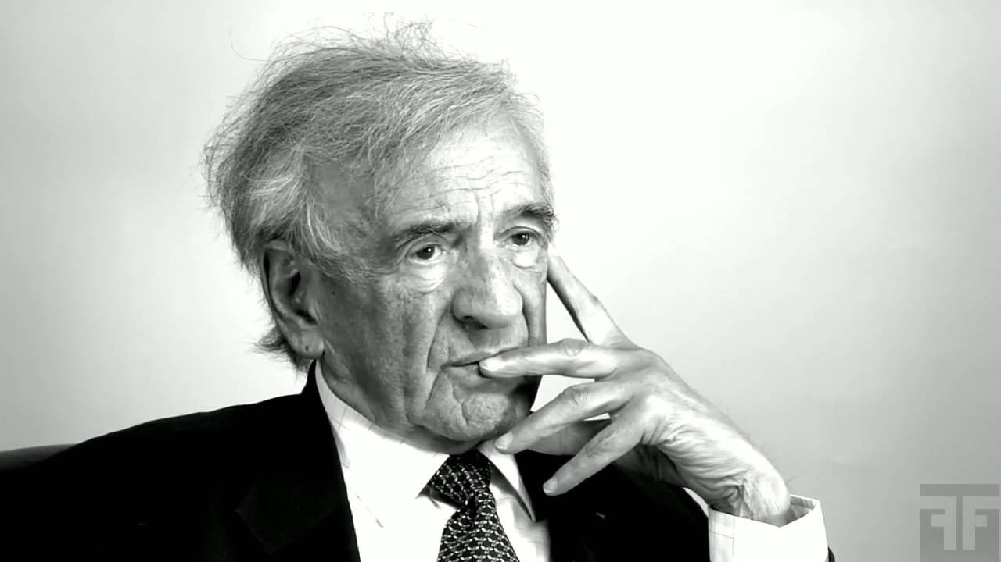
Rabbi Eli Wiesel

On the 29th of Nissan 1945 the Sixth Armored Division of the United States Third Army liberated the camp.
Among the more famous inmates who spent time in Buchenwald are Rabbi Israel Meir Lau, former Chief Rabbi of Israel, and Nobel Laureate Elie Wiesel.

Reprinted from this week’s email of Chabad.Org website.
Liberating Buchenwald
By Steve Eisenberg

Union, New Jersey, is a drab, grey, blue-collar town, not a place I would ordinarily visit. But a business meeting had been scheduled in this most unlikely place, so I left my usual stomping grounds in Manhattan and hopped a bus from Port Authority.
Now the meeting – which had ended badly – was over, and I was brooding about it, deep in thought, standing at a windswept bus stop with two other commuters – a middle aged woman and a stooped elderly man.
“When’s the next bus to Manhattan due?” the woman approached the man.
Perhaps the older gentleman was hard of hearing, or perhaps he was trying to collect his thoughts. At any rate, he didn’t answer immediately. Instead, he gazed at the woman with a blank stare.
She went ballistic. “You idiot! What’s the matter with you?! Don’t you have any common courtesy? What are you, stupid?” She went on and on, hurling a volley of insults, curses and epithets at the bewildered man.

He Noticed the Yarmulke on My Head
He looked at the yarmulke on my head, and motioned me to his side.
“Do you speak Yiddish?” he whispered in a thick, guttural accent.
I nodded yes.
“Ze’s an achta meshugenah.” (She’s crazy).
I smiled in commiseration.
The bus arrived, and I boarded quickly. I looked forward to my solitude and the opportunity to review the sequence of events that had led to the abysmal conclusion of the meeting. The bus was nearly empty, so I snuggled into a corner and closed my eyes.

Clearly Seeking Companionship
“Ah, so good to find a landsman in Union, New Jersey!” a voice sighed into my ear.
The elderly gentleman had settled into the seat next to me, clearly seeking companionship. “Not too many Jews in Union, you know. Where do you live?”
Probably a lonely Holocaust survivor, I thought. It’s a mitzvah to give him a little attention. I would have to reassemble my thoughts some other time.
“I live on the Upper West Side,” I said with a smile.
“Ah, the Upper West Side,” he said, fumbling for a connection. “Do you know Rabbi Schacter? Do you attend his shul?”
“You mean the Jewish Center? I don’t happen to attend that particular synagogue, but certainly I know of Rabbi Schacter. He’s a renowned and highly respected Rabbi. Why do you ask?”

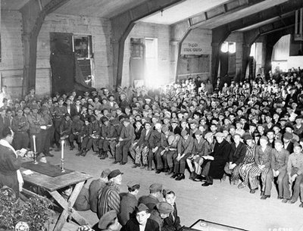

Rabbi Herschel Schacter, leading services for the
liberated inmates at Buchenwald in the Spring of 1945

“I knew his father – Rabbi Herschel Schacter,” the man said with obvious pride. “He was the one who liberated me from Buchenwald. I will never forget that day for as long as I live.”

“Can you tell me about it?” I asked eagerly. Holocaust stories have a particular resonance with me.
“Buchenwald was eerily quiet. We were all in our barracks, waiting for roll call. We didn’t see or hear any of the Nazi officers milling around, but we were still too afraid to venture outside to investigate. Then we heard the roar of military vehicles as the front ranks of the American troops stormed Buchenwald.
"Rabbi Herschel Schacter, the Jewish chaplain, was among the first to enter the gates. He immediately made his way to the administrative offices where the PA system was housed, and broadcast this message in Yiddish over the camp’s loudspeakers. I will never forget what he said: “‘Yidden (my fellow Jews, my brothers), its over. Yidden, you are free. Yidden, we are the American troops here to liberate you. Yidden, you can come out now.’

Most of us Thought it was a Trick
“But few of us did. We were frightened. Most of us thought it was a trick. We couldn’t really fathom that the nightmare had truly ended. I was one of the few who came forward, and I trailed behind Rabbi Schacter in wonderment as he began inspecting the camp with the American generals at his side. An American soldier who spoke Yiddish. Amazing!
“The American officers and Rabbi Schacter were clearly devastated by the carnage they saw. They walked around with dazed expressions of disbelief. With stricken eyes, they stared alternately at the mounds of corpses piled neatly in rows and the skeletons strewn haphazardly on the ground.
They reeled from the stench, from the furnaces still hot, from the ashes still smoldering in the air. Groans of horror, gasps of shock, continuously issued from their lips. Despite all the reports they had heard in advance, they had never conceived of or been prepared for such depravity, such evil, as they witnessed now.

A Slight Movement Caught His Eye
“At one point, Rabbi Schacter stood paralyzed in front of a mound of corpses, unable to go on. Suddenly, a slight movement caught his eye. He touched the arm of the general accompanying him. ‘I think I saw one of the corpses move,’ he trembled in excitement. ‘I think one of them is still alive!’
“‘Rabbi, it’s impossible,’ the general gently remonstrated him. ‘Even if the person was still alive when he was thrown into the pit, the weight of all the other bodies on top of him would have suffocated him to death.’
“’No, no no,” Rabbi Schacter insisted. ‘Don’t you see some movement? I see it, I see it even now!’
“’Rabbi,’ the general repeated patiently, ‘I know how much it would mean to you to be able to save even one life, but it’s your imagination, sir. All those people in the pit are dead.’

“But Rabbi Schacter was not easily persuaded. He drew closer to the mound of corpses, and began circling it slowly. It was then that he stumbled upon a small child, wide-eyed with fear, who had been hiding behind the pile of bodies, and whose slight motion Rabbi Schacter’s eagle eye had detected.

“I Have Found a Child!”
“‘I found a child! I found a child!’ he yelled to the officers. ‘A child in Buchewald, alive! It’s a miracle!’ He whooped joyously. Rabbi Schacter knelt down before the child, and embraced him gently. ‘What is your name, sweet child?’ he asked in Yiddish.
“’Lulek,’ the child answered, eyes averted.
‘And how old are you, Lulek?’ Rabbi Schacter asked tenderly.

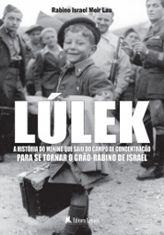
Rabbi Israel Meir Lau as the child Lulek

“’What’s the difference?’ the boy said sadly. ‘What are numbers? Believe me, with what I have seen, and what I have experienced, I am older than you. You can laugh and you can cry, but I can no longer do either.’

“Rabbi Schacter later discovered that the boy – perhaps the youngest known survivor of the concentration camps – was only eight years old. One and a half million innocent children had already been brutally murdered by the Nazis and against all odds, this one child had clung on to life.
The Nazis routinely killed all children who entered the camps, and the discovery of this lone child was both a shock and a triumph. A combination of miraculous circumstances and his own steely resolve had kept young Lulek alive.
“Rabbi Schacter insisted that Lulek stay at his side; he didn’t want to let him go. He asked Lulek to accompany him to the prisoners barracks, where the inmates were still hiding, so that he could personally reassure them that it was true: they were liberated, they were free, it was over. He held Lulek’s hand tightly as they walked from one barracks to another, announcing the same message over and over again: ‘Yidden, you are free. Yidden, it is over. Yidden, you are free.

“Do You Know who This Little
Child Lulek Turned Out to Be?”
“And do you know who this little child Lulek turned out to be?” the elderly gentleman asked me with a triumphant smile, as our bus rolled into Port Authority.
“Yisrael Meir Lau, Chief Rabbi of Israel!”

A few weeks later, I was rushing down the streets of the Upper West Side, trying to get to my shul for the afternoon prayer service of Mincha. When I realized I wouldn’t make it in time, I decided to duck into the nearest functioning synagogue. By chance, it happened to be The Jewish Center, presided over by Rabbi Jacob Schacter, Rabbi Hershel Schacter’s son.
After mincha, we crossed paths, and I told Rabbi Schacter of my encounter on the bus with the Buchenwald survivor. As I recounted the survivor’s tale, Rabbi Schacter began weeping, and he pumped my hand in gratitude.

“You Have Given Me a Gift”
“You know, my father told me this story 30 years ago,” he said, “and of course, I believed him. But it means so much to me to have it corroborated by a witness, and to hear the events that occurred depicted from this man’s perspective. You don’t know what this means to me. You have given me a gift.”
Just a short time after this conversation took place, I traveled to the Catskills for the weekend and stayed at a summer resort called Vacation Village. Every Sabbath, Vacation Village hosts a different distinguished guest, and unbeknownst to myself, the scholar in residence on that particular weekend just happened to be Rabbi Herschel Schacter, liberator of Buchenwald.
After his speech ended, I raised my hand and asked if I might recount a story that I had recently heard about his experiences in Buchenwald. He graciously gave his assent, and I proceeded with my tale. I felt privileged to be able to tell the 400 people in the audience how Rabbi Schacter was responsible for the rescue and well-being of the current Chief Rabbi of Israel.

Stunned by Who Was Seated at the Dais
There was only a short interval that lapsed between this and my final experience with the story. Not many days had passed when I was summoned to a fund-raising dinner I was reluctant to attend. My tentativeness, however, immediately vanished, when I entered the ballroom and saw on the dais none other than Lulek – Rabbi Yisrael Meir Lau, the Chief Rabbi of Israel. Sitting next to him was... Rabbi Herschel Schacter.
Rabbi Lau was called to the podium to deliver a speech, but before he launched into his opening remarks, he introduced Rabbi Schacter to the audience. “You see this man over here?” he pointed to the Buchenwald liberator. “He saved my life.”

Rabbi Herschel Schacter recently passed away at the age of 95.

Reprinted from this week’s email of Aish.com Excerpted from "Small Miracles from the Holocaust," by Yitta Halberstam and Judith Leventhal.

Who's Who – Aharon Kohen Gadol
Aaron (Aharon) was the elder brother of Moses and the first High Priest - Kohen Gadol - of the Jewish people. He was appointed by G-d to minister in the Sanctuary and to serve as a conduit for G-d's blessings to His people.
At the age of 83, he joined his brother in the great mission of freeing the Jews from Egypt. As Moses was unable to speak properly, Aaron served as his spokesman before Pharaoh. Aaron was the epitome of love for his fellow Jew, exerting himself torecon cile disputants, and "pursuing peace." At his death, all the people mourned him deeply for 30 days.

Reprinted from last week’s edition of “L’Chaim,” a publication of the Lubavitch Youth Organization.
A Tribute to
Margaret Thatcher
By Sara Debbie Gutfreund

Her Proudest Moment was
Saving an Austrian Jew.

When Margaret Thatcher passed away today [April 8, 2013], the tributes began pouring in from all over the world. Mrs. Thatcher was Britain’s first female prime minister, serving for 11 years starting in 1979. Known as the Iron Lady, she was a strong Conservative who changed England’s perspective on its economic and political life.

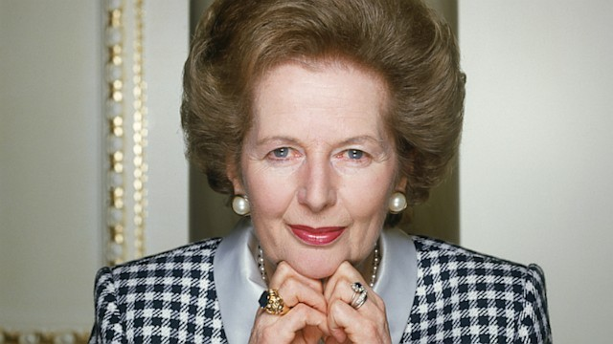Former British Prime Minister Margaret Thatcher

Despite her many impressive accomplishments, including fighting the Soviet communist regime, Thatcher said that her proudest moment was when she saved a Jewish teenager from Austria during the Holocaust.
In 1938, Edith Muhlbauer, a 17-year-old Jewish girl, sent a letter to Muriel Roberts, Edith’s pen pal and the older sister of Margaret Thatcher, asking if the Roberts family could help her escape from Austria. The Nazis had started rounding up Jews from Vienna and Edith knew it was just a matter of time before she would be among them.
Alfred Roberts, the father of Muriel and Margaret, was a grocer in a small town. They lived in a cold water flat above the grocery with an outhouse; the Roberts did not have the time or the money to bring Edith to their home.

Decided to Try and Raise Money
To Bring Edith Over to England
So Margaret, then 12 and Muriel, 17, decided to try raising money and asking the local Rotary club to help. They succeeded in bringing Edith to England where she stayed with several Rotary families, including the Roberts for the next two years before joining relatives in South America.
Edith slept in Margaret’s room and Thatcher later wrote in her memoir: “She was tall, beautiful, evidently from a well to do family. But most important, she told us what it was like to live as a Jew under an anti-Semitic regime. One thing Edith reported particularly stuck in my mind. The Jews, she said, were being made to scrub the streets.”
In 1995, after Edith had been located in Brazil, she told audiences, “Never hesitate to do whatever you can for you may save a life.”

Now a Jewish Grandmother in Sao Paolo
Edith is now a Jewish grandmother in Sao Paolo who says that she owes her life and the life of her children and grandchildren to Margaret Thatcher’s family. When Thatcher visited Yad Vashem during a historic, first visit to Israel by a British prime minister in 1986, she was visibly shaken as she stood in front of a photo of a German soldier shooting a Jewish mother and child. She exclaimed, “It is so terrible. Everyone should come and see it so that they never forget. I am not quite sure whether the new generation really knows what we are fighting against.”
Thatcher continued to be a loyal friend to the Jews as she fought the British support for the Arab boycott of Israel, protested on behalf of Jewish refuseniks in the Soviet Union and chose several Jewish leaders to be part of her cabinet.
Thatcher admired the hard work and self-reliance of the British Jewish community and frequently turned to England’s late chief rabbi, Immanuel Jakobovits for spiritual back up. She even elevated Rabbi Jakobovits to the House of the Lords and he later became known as “Thatcher’s rabbi.”
Thatcher also made the following statement about Israel’s security: “Israel must never be expected to jeopardize her security; if she was ever foolish enough to do so and then suffered for it, the backlash against both honest brokers and Palestinians would be immense - ‘land for peace’ must also bring peace.”
Thatcher spoke up with such courage and strength because as she described herself, “This lady is not for turning.” When she believed in an ideal, whether it was transforming the British economy or saving a terrified Jew from Austria, she was not afraid to follow through, even if she had to stand up against popular opinions to do so.

Four Famous Quotes
Thatcher’s integrity that inspired her to save Edith when she was just 12 years old shines through four of her most famous quotes that can teach us invaluable life lessons:
Let your actions speak louder than your words: “Being powerful is like being a lady. If you have to tell people you are, you aren’t.”
Stand up for what you believe in: “If you just set out to be liked, you would be prepared to compromise on anything at any time and you would achieve nothing.”
Don’t give up: “You might have to fight a battle more than once to win it.”
We can all be leaders: “People think that at the top there isn’t much room. They tend to think of it as an Everest. My message is that there is tons of room at the top.”

The Power of Belief in What One Can Do
There were so many reasons why twelve year old Margaret and her sister could have thrown up their hands in despair and stuffed Edith’s letter into a drawer in their tiny, freezing apartment. They had no money, no power and no idea how they would be able to rescue this terrified girl that they had never met.
But they believed that they could and should do everything that they can to help. They knew even then that there was room in the world for great leaders, even if they were only twelve years old and living above a small town grocery store with no hot water.
We pay tribute to Margaret Thatcher for her friendship and work with the Jewish people. For her wise words and inspiring courage. And for teaching us, that above all else, the greatest achievement in life is sometimes not one that earns you a trophy or money or even a powerful position. Sometimes it’s the quiet, determined accomplishments that no one hears about until years later.

Reprinted from this week’s email of Aish.com

